Health Care Plus: Incident Response Plan

Submitted By (Group 5):
Vinitha Kalabathula, Varun Koundinya Kotar, Dhruv Prajapati, Vivek Harsha Vardhan Tumma, Shanmukha Maneeshbabu Uppala

University of Maryland, Baltimore County
CYBR 650: Managing Cyber Security Operations
Ronald Nemes
November 14th, 2023

Introduction:
The HealthCare Plus Incident Response Plan is a strategic framework designed to ensure the security of patient information and the continuity of high-quality medical services. It outlines a systematic approach to detecting, managing, and recovering from security incidents in compliance with HIPAA and HITECH regulations. The plan prioritizes timely and efficient responses to a wide range of cybersecurity events that could impact patient data and healthcare delivery. Our commitment to this plan underscores our dedication to safeguarding patient well-being and data integrity in our medium-sized healthcare organization.
- Planning Phase:
1.1 Background:
HealthCare Plus, based in New York City, is a medium-sized healthcare organization serving approximately 10,000 active patients and generating an annual turnover of $5 million. Specializing in general healthcare, specialty treatments, and diagnostic services, the organization operates in a highly regulated industry. Compliance with regulations like HIPAA and HITECH is essential for protecting patient data and providing high-quality healthcare.
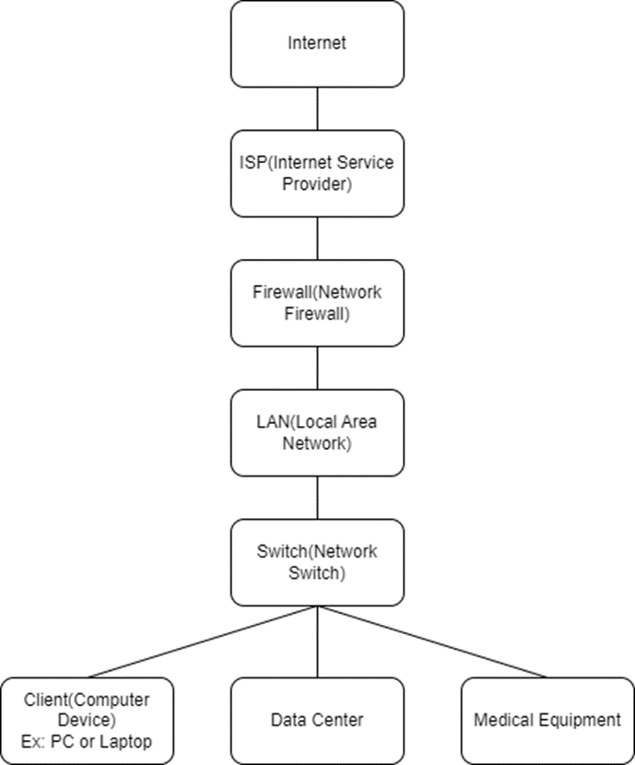
Network Diagram of IT Infrastructure
HealthCare Plus has a specialized Computer Security Incident Response Team (CSIRT) to handle possible security incidents. An internal group of experts known as the CSIRT oversees handling cybersecurity-related problems inside the company. The group works around the clock because they understand how important healthcare services are and how quickly security events must be handled.
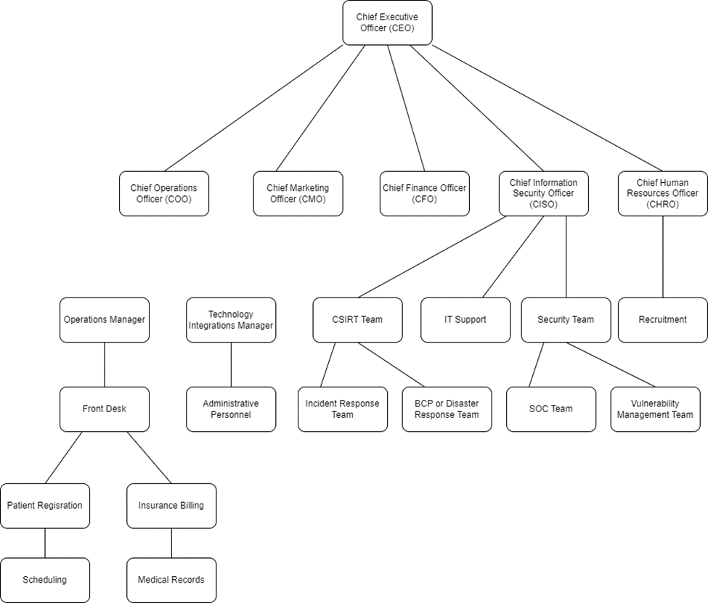
1.2 CSIRT Team Description:
Local vs. Partial Outsource vs. Full-Outsource:
Why We Chose a Local Team: The requirement for a committed, competent, and devoted team of professionals who are well-versed in HealthCare Plus's particular environment led to the decision to choose a local, in-house CSIRT team.
Local Team Advantages:
In-Depth Organizational Knowledge: An internal, local CSIRT team is well-versed in the IT infrastructure, applications, and security requirements of the company.
Dedication and Commitment: Employees working for the company are frequently more committed to its vision and objective, which include protecting patient information.
Local Team Disadvantages:
Resource Allocation: Maintaining an internal team can be expensive, especially when it comes to staffing and continuous training.
Expertise and Skill Gaps: The local staff may require continuous training and upskilling to keep up with the latest cybersecurity risks and technology.
Hours of Operations:
Shift-Based Schedule: The CSIRT staff works in shifts to ensure round-the-clock coverage. To guarantee that staff are always accessible for incident response, day or night, shifts are rotated. This strategy ensures that security issues are attended to promptly and reduces the possibility of fatigue-related response delays.
Work Schedule Details: The IRP should include information on shift lengths and rotation intervals. One possible structure for shifts could be an 8-hour rotation, where employees rotate to a different shift once a week. Regular rotation is possible with this timetable without resulting in excessive stress or exhaustion.
Shift-Based Schedule: Shift 1: 12:00 AM - 8:00 AM, Shift 2: 8:00 AM - 4:00 PM, Shift 3: 4:00 PM - 12:00 AM
12-Hour Rotations (Day/Night Shifts): Shift A: 7:00 AM - 7:00 PM, Shift B: 7:00 PM - 7:00 AM
Work Schedule Details:
Shift Rotation: Members of the team alternate between shifts in an organized way. Employees may, for instance, perform a specific shift for a week before switching to the next one.
Day Off: Team members usually receive a set number of days off after working a shift so they can relax and recuperate before beginning their next shift. This assures that throughout their on-duty hours, individuals stay focused and productive.
Overtime and On-Call: Certain team members might be put on an on-call rotation in the event of serious incidents or the need for additional help. They must be on call to handle emergencies outside of their regular work hours. The IRP should contain policies regarding on-call duty and overtime pay.
1.3 Central vs. Distributed vs. Coordinating:
Central Model: In a central model, the organization's headquarters serves as the sole location of the CSIRT team. With this strategy, all incident response operations are centralized, standardized, and optimized from a single location.
Why We Chose a Central Model: To ensure a uniform and cohesive reaction to security events, a centralized CSIRT approach is chosen. By lowering the possibility of contradictions and misunderstandings during the incident-handling process, centralization increases team productivity and guarantees that everyone is working together to achieve shared objectives. It is consistent with HealthCare Plus's dedication to service continuity and patient data protection.
By ensuring that all parties involved are aware of the reasons behind and advantages of these decisions, this transparency helps HealthCare Plus respond to incidents more effectively.

Detection and Analysis
2.1 Types of Tools and Placement:
Intrusion Detection Systems (IDS)
- Placement: To enhance network security, we will deploy Intrusion Detection Systems (IDS) sensors at critical locations within our network. These locations include the network perimeter, between different network segments, and in proximity to our Electronic Health Record (EHR) servers.
- Functionality: IDS sensors serve as vigilant sentinels for our network. They are equipped to detect any unusual or malicious network traffic patterns, which could signify a potential security incident. Two primary types of IDS are at our disposal: network-based IDS, which monitors network traffic, and host-based IDS.
Intrusion Prevention Systems (IPS)
- Placement: Intrusion Prevention Systems (IPS) will be strategically positioned at key junctures within our network infrastructure. These strategic locations include the network perimeter, which serves as the first line of defense against external threats, and near our critical systems, most notably our Electronic Health Record (EHR) servers.
- Functionality: IPS devices serve as proactive gatekeepers for our network security. Their role goes beyond mere detection; they possess the capability to take immediate and decisive actions to block or mitigate potential threats in real-time. These actions can include but are not limited to, blocking suspicious network traffic, isolating compromised systems, or triggering alerts for immediate response.
Endpoint Detection and Response (EDR) Solutions
- Deployment: To fortify the security of our network, we will implement Endpoint Detection and Response (EDR) solutions. These solutions will entail the installation of specialized EDR agents on every one of the 20 computers utilized by our front desk staff, administrative personnel, and any other devices that are interconnected with our network.
- Functionality: EDR solutions are a vital component of our security strategy as they offer a granular level of visibility and monitoring at the endpoint level. This means that each device, including workstations used by our front desk and administrative staff, is continuously scrutinized for any signs of suspicious activity or potential security breaches.
Security Information and Event Management (SIEM)
- Deployment: As part of our comprehensive security strategy, we will deploy Security Information and Event Management (SIEM) systems. This implementation involves setting up SIEM solutions to create a centralized hub for collecting, storing, and correlating logs and security events from various sources across our network.
- Functionality: The different functions offered by SIEM systems are Centralized Log Collection, Real-time analysis, Alerting and notification, Correlation of events, Incident response support, and Compliance monitoring. SIEM systems play a pivotal role in our security strategy by offering these functions.
2.2 Reporting Procedures (How to Report and To Whom)
- Employees: Reporting can be done through various accessible and convenient channels, including phone, email, or a dedicated incident reporting platform. By encouraging employees to report, we foster a proactive and collaborative security culture within the organization, where everyone is a vigilant defender of our data and network.
- CSIRT Team: The internal Computer Security Incident Response Team (CSIRT) at HealthCare Plus is our dedicated unit responsible for receiving and managing incident reports. When an incident is reported, the CSIRT team will promptly swing into action.
- Management: Major incidents or those that may carry potential regulatory implications are subject to reporting to executive management. This includes the CEO and the Chief Information Officer (CIO).
- Regulatory Authorities: Incidents that involve potential data breaches or violations of healthcare regulations, such as the Health Insurance Portability and Accountability Act (HIPAA), must be reported to the relevant regulatory authorities as mandated by law.
- Law Enforcement: In cases where an incident involves criminal activity, such as a data breach with evidence of malicious intent, it is crucial to report these incidents to law enforcement agencies. This includes local police or federal agencies like the Federal Bureau of Investigation (FBI) for further investigation and potential legal action.
2.3 Report Template
An incident report template should have the following key elements:
- Incident description.
- Detection time.
- Severity Classification.
- Actions taken.
- Impact Assessment.
- Recommendations for future prevention.

- Response:
- Containment: In this step, all possible methods are used to prevent the incident or event from spreading across the network. Actions might include disconnecting systems from networks, quarantining infected systems, or blocking traffic to and from known malicious IP addresses.
- Eradication: After you have contained the threat, it is time to eliminate any lingering traces. Delete malware, remove the malicious code, devices, or software, and disable breached accounts. Reduce any weaknesses the attack will expose. This could involve using manual eradication techniques or anti-virus software.
- Recovery: In recovery, administrators restore systems to normal operation, confirm that the systems are functioning normally, and remediate vulnerabilities to prevent similar incidents. Recovery may involve such actions as restoring systems from clean backups, rebuilding systems from scratch, replacing compromised files with clean versions, installing patches, changing passwords, and tightening network perimeter security.
Categorization of incidents: Classifying occurrences for response, such as prevention, eradication, and recovery, is necessary for effective incident management. The classification system you choose may vary depending on the needs of the organization and the specific incidents you are dealing with. Here, we are using a general approach that uses a tiered system, with level or severity labels such as low, medium, and high.
Levels | Description
Level 0 (None) | No effect on the organization’s ability to provide all services to all users
Level 1 (Low) | Events that have minimal impact on operations, data, or assets and that can be easily controlled and resolved. Only requires a limited amount of resources or expertise to handle.
Level 2 (Medium) | Incidents that have a moderate impact on operations, data, or assets, and may require some effort to control and resolve. Not serious but requires attention.
Level 3 (High) | Critical events need to be addressed right away because they could seriously affect operations, data, or assets. It often requires a large amount of resources and experience to prevent and resolve such disasters.

How are incidents escalated?
An incident escalation procedure is essential to making sure that problems are properly handled and resolved in a timely and effective manner. It involves moving an incident from a lower level of response to a higher level, typically to escalate the incident's severity or the resources and expertise involved in its response. Organizations should also establish an escalation process when the IR team does not respond to an incident within the designated time. If the IR team does not respond within a certain time, then the incident should be escalated again to a higher level of management. This process should be repeated until someone responds. Here is a summary of how incidents are escalated:
1. Initial Reporting and Assessment: An incident is initially reported by employees, IT staff, or security teams who detect or suspect an incident. The incident response team or designated personnel assess the incident's severity, impact, and threat level based on predefined criteria. This assessment helps determine the appropriate level of response.
2. Escalation Criteria: Organizations establish clear escalation criteria to decide when an incident should be escalated. These criteria generally consider factors such as the severity, impact, complexity or need for special expertise of the incident.
3. Escalation Levels: Incidents can be escalated to different levels depending on their severity and the response required. These levels often include Level 1 (low), Level 2 (moderate), and Level 3 (high), as described in the classification system above.
4. Incident Response Plan: Each escalation level should have a corresponding incident response plan that outlines the prevention, reduction, and recovery procedures for that level of incident severity.
5. Notification and Communication: As incidents escalate, relevant stakeholders are informed. This may include senior management, legal teams, public relations, and regulatory bodies, depending on the nature and severity of the incident.
6. Resource Allocation: As incidents escalate, more resources can be allocated according to the escalation level and incident response plan, such as additional personnel, technology, or external cybersecurity experts.
7. Monitoring and Reporting: Continuous monitoring of the progress of the incident and the effectiveness of prevention, eradication, and recovery efforts is essential. Regular updates and status reports are communicated to the incident response team and relevant stakeholders.
8. Resolution: Once the incident is controlled, eliminated, and recovery efforts are well underway, it can be de-escalated, and after confirming that the threat has been neutralized and the damage minimized. is, normal operations can resume.

Responses and procedures:
The plan requires specific skills for different types of incidents, and the Incident Response Planning Team (IRPT) is responsible for identifying necessary expertise and assembling appropriate response teams for each scenario. This approach ensures structured and efficient incident management, minimizing damage and enhancing organizational resilience.
Incident 1: Data Breach
Incident level: Level 3 (High Level)
Response Procedures:
· Immediately isolate affected systems or network segments to prevent further data exposure.
· Examine system logs, application logs, and security logs for any unusual or unauthorized activities
· Identify and classify the data that has been breached.
· Halt the unauthorized data transfer process to prevent further data leakage.
· Preserve evidence for potential legal actions.
· Notify the incident response team and key stakeholders.
· Contain the incident by securing the breached systems and closing any vulnerabilities.
· Eradicate any unauthorized access and remove malicious actors from the network.

Incident 2: DoS Attack
Incident level: Level 2 (Medium)
Response Procedures:
· Work with your ISP or DDoS protection service to filter and block malicious traffic before it reaches your network.
· Set Up Auto-Scaling or Load Balancing
· Run anti-DoS hardware or software to stop unwanted request
· Monitor network traffic continuously for effectiveness and adjust mitigation measures as needed.
· Analyze the nature of the attack to determine its source and methods.
· Communicate with affected customers, clients, or users about the incident and its impact

Incident 3: Fire
Incident level: Level 3 (High Level)
Response Procedures:
· Ensure the safety of all personnel and occupants by following established safety protocols and evacuation plans.
· Immediately execute emergency evacuation plan
· Assess the physical damage to facilities and infrastructure.
· Secure critical infrastructure to prevent further damage.
· Activate disaster recovery and business continuity plans.
· Notify relevant authorities, emergency services, and key stakeholders about the situation.
- Post-Incident Activity:
In healthcare, capturing key information in an after-action report (AAR) or lessons learned is critical for continuous improvement and to prevent the recurrence of incidents. These reports help healthcare organizations identify what worked well and what areas need improvement. what should be captured in an after-action report or lessons learned in healthcare:
These will be the main components:
1. Incident overview​. What happened, when did it happen, how did it happen, etc.
2. Analysis. What was observed? What was expected? Was anything unexpected? Who was involved in the incident? What are the strengths? What are the areas of opportunity? The analysis portion of your post-action report should be the longest and most detailed portion of your report.
3. Recommendations. In the recommendations section of your report, detail ways to improve performance for future incidences to secure the information.
4. Improvement/action plan. You will have corrective actions to be taken for future incidents. Be sure to include any additional training requirements, equipment needs, or any additional planning that needs to be completed.
- Incident Description: Start with a detailed description of the incident, including date, time, location, and any relevant information. Provide a clear overview of the incident.
- Impact Assessment: Describe the impact of the incident, including the number of patients affected, the severity of harm, and any other consequences. Assess the financial, operational, natural, and reputational impact as well.
- Response Timeline: Create a chronological timeline of key events during the incident response process. Note when the incident was first detected, when the CSIRT team was alerted, and the sequence of actions taken.
- Issues and Challenges: Identify and document the challenges and issues encountered during the response. This can include resource shortages, communication breakdowns, or any unexpected obstacles.
- Decision-Making: Analyze the decision-making process during the incident response. Assess the quality of decision-making, any changes in plans, and the rationale behind key decisions.
- Resource Allocation: Document how resources, including staff, equipment, and supplies, were allocated during the incident. Analyze whether resources were deployed effectively and efficiently.
- Regulatory Compliance: Ensure compliance with relevant healthcare regulations and protocols. Highlight any areas where compliance was achieved or where deviations occurred.
- Accountability: Assign responsibility for implementing the recommendations. Identify who is responsible for each action item and set deadlines for completion.
- Follow-Up and Monitoring: Describe the process for monitoring the implementation of recommendations and assessing their effectiveness. Specify how progress will be tracked and reported.
- Documentation: Ensure that all actions and decisions made during the incident are thoroughly documented. Evaluate the quality of documentation and identify areas for improvement.
- Training and Awareness: Review the training and awareness programs in place for incident response. Identify any knowledge or skill gaps that became apparent during the incident.
- Regulatory Compliance: Assess how well the organization adhered to relevant regulations, such as HIPAA and HITECH, during the incident response. Document any compliance issues that arose.
- Closing Remarks: The AAR for HealthCare Plus concludes with a summary of the incident and a reaffirmation of the organization's commitment to continually improving incident response, ensuring enhanced protection of patient data and reliable healthcare services in future incidents.

References:
- Cichonski, P., Millar, T., Grance, T., & Scarfone, K. (2012). Computer Security Incident Handling Guide. NIST Special Publication, 800-61, 79.
- Killcrece, G., Kossakowski, K. P., Ruefle, R., & Zajicek, M. (2003). State of the practice of computer security incident response teams (CSIRTs). Carnegie-Mellon Univ Pittsburgh PA Software Engineering Inst.
- https://rems.ed.gov/docs/AfterActionReportsFactSheet_508C.pdf
- Monnappa, K. A. (2018). Learning Malware Analysis: Explore the concepts, tools, and techniques to analyze and investigate Windows malware. Packt Publishing Ltd. https://books.google.com/books?hl=en&lr=&id=QsNiDwAAQBAJ&oi=fnd&pg=PP1&dq=CSIRT+and+IRP+Detection+tools+and+methodologies+Types+of+tools+and+placement+&ots=FJQuDomr6I&sig=jvOUxi86qQD6fPdgVRi22hG0U90#v=onepage&q&f=false
- Kjærem, I. (2005). Benchmarking CSIRT work processes (Master's thesis).
https://ntnuopen.ntnu.no/ntnu-xmlui/bitstream/handle/11250/143898/Kj%C3%A6rem%20-%20Benchmarking%20CSIRT%20work%20processes.pdf?sequence=1

